Using publicly available data, highlight one pitcher or position player who you believe will take a step forward next season.
To answer this question, I built a predictive model using data from FanGraphs. The goal of this model was to estimate the probability that a hitter would “break out” in this next year. I defined breaking out as having a jump of 2 or more in WAR. Based on this model and further analysis I decided that Jordan Walker, a right fielder from the St. Louis Cardinals would be a very strong option to break out this next year. The programming language I used for this problem was R and I used R Studio.
The data I used for this model was from the “baseballr” library by Bill Petti. (https://billpetti.github.io/baseballr/) With this package, I used the fg_batter_leaders function. When I called this function, it returned all hitters from a certain season with at least 200 plate appearances. With this function, I stored the fangraphs data from the 2023, 2024, and 2025 seasons into their own data frames.
I first started with cleaning the data. There were initially 350 columns of data for each player. To make this number more manageable, I grouped each variable into a category (i.e. batted_ball_vars, discipline_vars, contact_quality_vars). I then created a final list of variables, all of which I would use as predictor variables and named this “predictor_vars”. This final list ended up being 48 predictor variables that I would use in my model.
For this model, I created a response variable, named “did_breakout”. To do this, I joined the WAR value from the 2024 dataframe to the 2023 dataframe by player. If they did not have data in 2024 then I would not keep them in the 2023 data. If a certain player’s 2024 WAR was greater than or equal to 2 larger than their 2023 WAR then I would give them a 1 for did_breakout, if their WAR did not meet that criteria then I would give them a 0. I did the same thing for the 2024 dataset with the 2025 WAR variables.
I then researched what type of model would work well for this, and since there were many variables, as well as many correlated variables, then Elastic Net Regression would be the best option. Elastic Ridge combines the techniques from both Ridge and Lasso Regression. Since the variable that we are predicting is a 1 or 0, we are going to use Elastic Net Logistic Regression.
I trained the model on the 2023 data and then tested it on the 2024 data. The model achieved an AUC score of 0.635. To explain this value, if we chose one random hitter that did break out and one hitter that did not break out. The model would give a higher probability of breaking out to the correct player 63.5% of the time, which is much better than random guessing (50/50). Because these breakouts are rare and have a lot of outside variance (playing time, possible injury), this value of .635 is very good.
After doing the model evaluation, I moved on to predicting the 2025 data. I ran the model, and listed the top 10 candidates. I excluded all people who had >3 war seasons in 2025 because I did not see many of them taking a step forward. This next picture is the top 10 candidates from that model.
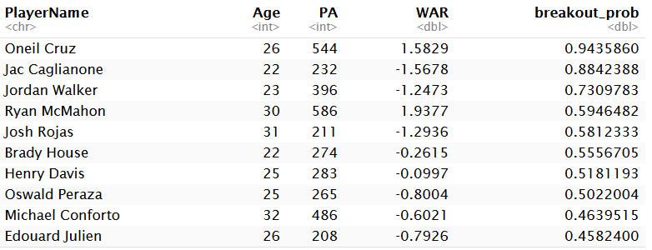
This picture shows the Player’s name, age, how many plate appearances they had in 2025, how much WAR they had in 2025 and their “breakout probability” based off of my model. I took a look at my model predictions from 2024 as well, and Oneil Cruz was at the top of the list for that as well, and he ended up not breaking out. Jac Caglianone is a very new player and I do believe that he could be a great player, but I wanted to choose someone who has been in the league for at least a couple of years. So, I ended up going with Jordan Walker.
Jordan Walker is a right fielder for the St. Louis Cardinals. He was drafted in the first round of the 2020 draft and has so far played 3 years in the MLB and has a total of -.9 F-WAR. I ran a coefficient analysis on this player to find which coefficients were the leading factors in his .73 value for “breakout_prob”. The next picture is showing the top 10 contributing coefficients.
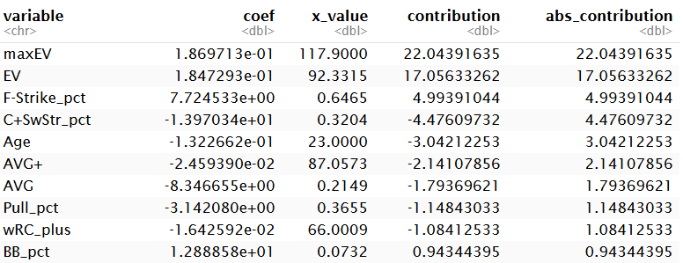
This picture is showing which coefficients are contributing to Jordan Walker’s, showing the variable name, Walker’s value (x_value), and how much it is contributing to his final value. I used the absolute value of the contribution to show which values changed the final probability the most. Looking at each variable we can see that Walker has a very high upside with how hard he hits the ball, with the highest contributing coefficients being his maximum exit velocity and his average exit velocity. The next values we can take a look at are the AVG variables. Since these variables have negative coefficients, the higher “AVG+” and “AVG” variables that a player has, then he has a lower chance of breaking out in the next season. Since Walker has a low batting average, 13% below league average according to his AVG+, he has less of a chance not to break out.
After taking a look at Walker’s coefficients, I wanted to take a look at his pitch level data and create some visualizations to further look at his statistics. For this data I did a search on baseballsavant.mlb.com and downloaded his data for every pitch he faced in 2025. I downloaded this data into a comma separated value (.csv) file, and imported it into my R file using read.csv.
The first visualization I made was a scatterplot of each batted ball’s launch angle vs exit velocity. I colored the plot based off of each values xwOBA, I also shaded the region where a certain hit would be classified as a “Barrel”.
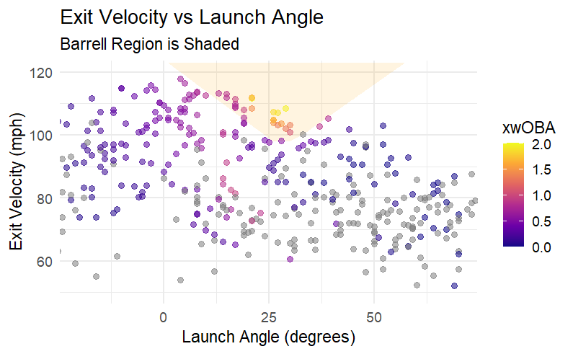
From this plot we can see that Walker hits the ball very hard, but hits a lot of ground balls. From the x axis we can see that most hard hit values are in the -10 to 25 degree range. This will generate a lot of line drives, but a lot of ground balls. From this plot I moved on to calculating his average launch angle. This turned out to be 10.3 degrees. This is a concerning value for someone who hits the ball as hard as he does. I looked for a good comparison for Walker in his current stage and what I found is that 2020 Kyle Schwarber had a 8.8 degree average launch angle and was a below average hitter according to Batting Value. In the next few years his average launch angle improved from 8.8 degrees to 19 degrees, and he ended up becoming an MVP candidate.
After this, I created some strike zone plots for his expected statistics. I created plots for xBA, xSLG, and xwOBA. They are pictured below.
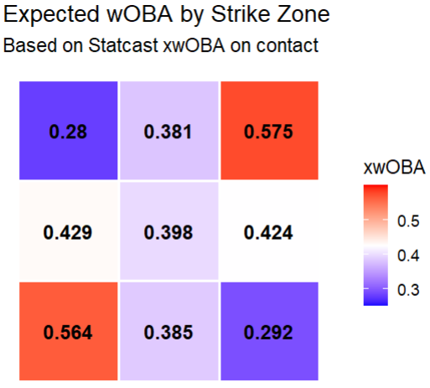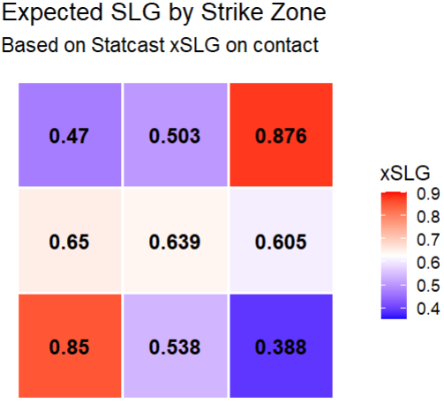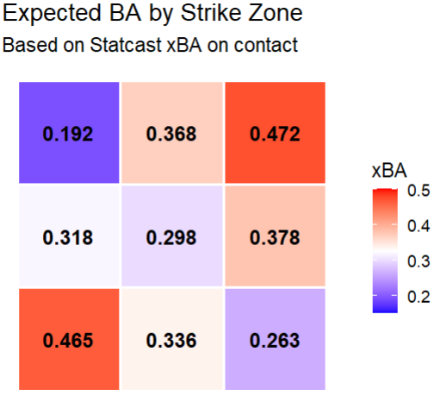
Based off of these plots, I believe that Walker should try to attack the pitches that are in the top part of the zone more. His xBA is higher in the top third of the zone, but then his xSLG values are lower for that area. These should be the zones that he attacks and hits the ball far in the air. Another thing is that he should look to punish pitches that are directly in the middle of the zone more. That area shows lower values across the board.
My conclusion on this question is that Jordan Walker is a very strong person. His bat speed is in the 99th percentile but his whiff rate is in the 1st percentile. If he can make a little bit more consistent contact while putting the ball in the air more. He could easily jump 2 or more WAR. I believe that he could even become one of the best hitters in the game of baseball.

